accessibility UPDATE October 2026

Accessibility Programme of Works Update
Boyle Station
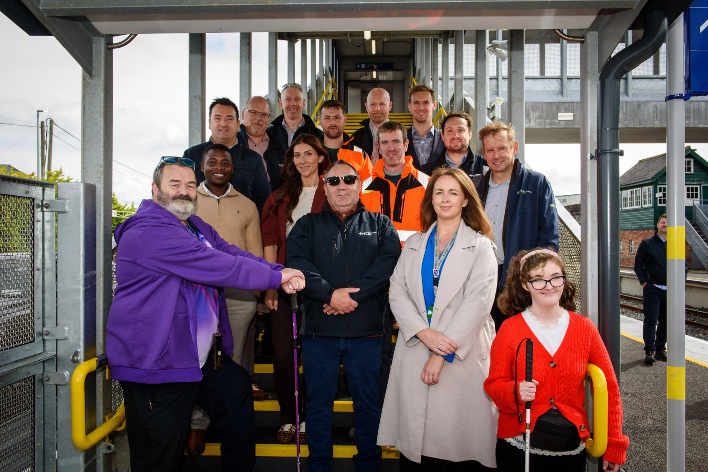
Photo above: Members of the Disability User Group (DUG) with Iarnród Éireann staff.
On 21 August, Iarnród Éireann marked the completion of a major accessibility upgrade at Boyle Station.
As part of Iarnród Éireann's ongoing Accessibility Programme, and funded by the Department of Transport through the National Transport Authority, the works completed over the past year include:
- A new pedestrian footbridge over the railway, equipped with two 13-person lifts.
- Remedial works on Platforms 1 and 2.
- Redesign and enhancement of accessible parking spaces adjacent to the station building.
- Upgraded station lighting around the station building and new footbridge.
- Enhanced wayfinding and tactile signage, including a tactile station map at the station entrance.
- Installation of help points and induction loops connected to the existing public address system.
- Significant improvements to toilet facilities.
Iarnród Éireann continues to invest in improving accessibility across its stations and services. The Disability User Group (DUG) plays an important role in providing direct feedback from disability representative organisations and rail users, helping to shape accessibility programmes and projects.
Pictured above are DUG members Gary Kearney and Roisin Lenehan.
In addition to Boyle Station, accessibility projects have recently been completed at Athy and Rathmore, while works continue at Claremorris, Dromod, and Longford stations.

Customer Accessibility Solution – Partnership with Transreport
Iarnród Éireann is working with Transreport to introduce a new Passenger Assistance System across the rail network for customers who require assistance, including customers with disabilities.
The new platform will strengthen the way assisted travel is managed and coordinated. Accessible via a mobile app, website, or call centre, it will give customers greater visibility of their assistance requests while helping station and onboard teams coordinate support more effectively throughout the journey.
Disability User Group member Barry welcomed the initiative:
"The Customer Accessibility Solution is a very welcome development for passengers with disabilities and reduced mobility. Being able to pre-book assistance through a smartphone app, website, or the TFI Call Centre ensures accessibility for all. The reassurance of knowing that an assistance request has been logged is extremely valuable. It also helps align customer expectations with staff availability, both in stations and onboard trains, while allowing resources to be scaled up when demand increases."

Disability User Group Review
An independent review of Iarnród Éireann's Disability User Group was recently conducted by Corporate Governance. The review found that the strong working relationship between accessibility staff and DUG members is a significant strength.
The review also acknowledged the complexity of delivering accessibility improvements within a rail environment, where competing access requirements, mandatory standards, protected structures, procurement lead times, and multi-agency delivery arrangements must all be considered.
A key finding was that the Group delivered the greatest value through site visits, mock-ups, user testing, and direct engagement with project teams, rather than through formal meetings. The review identified opportunities to strengthen group governance, noting that there are currently no published membership criteria, nomination process, defined membership size, or fixed terms of service.
Three future options were outlined:
- Discontinue the Group and engage directly with disabled people and representative organisations.
- Continue the Group in its current format.
- Reconstitute the Group with formal governance arrangements.
These options are currently under consideration by Iarnród Éireann.
Indoor Navigation Pilot

Members of the Disability User Group recently participated in a pilot of GoodMaps, a camera-based indoor navigation technology, at the Vision Ireland Wayfinding Centre in Glasnevin.
The pilot was supported by Iarnród Éireann's Human Factors Team, who gathered user feedback throughout the exercise.
A follow-up pilot was subsequently held at Connolly Station, where participants provided valuable insights to support future development and accessibility improvements.

Age Friendly Stations
A walkability audit of Edgeworthstown Station took place during the summer in partnership with Age Friendly Ireland.
The event generated excellent feedback and valuable recommendations to help improve accessibility and ease of movement within the station environment.
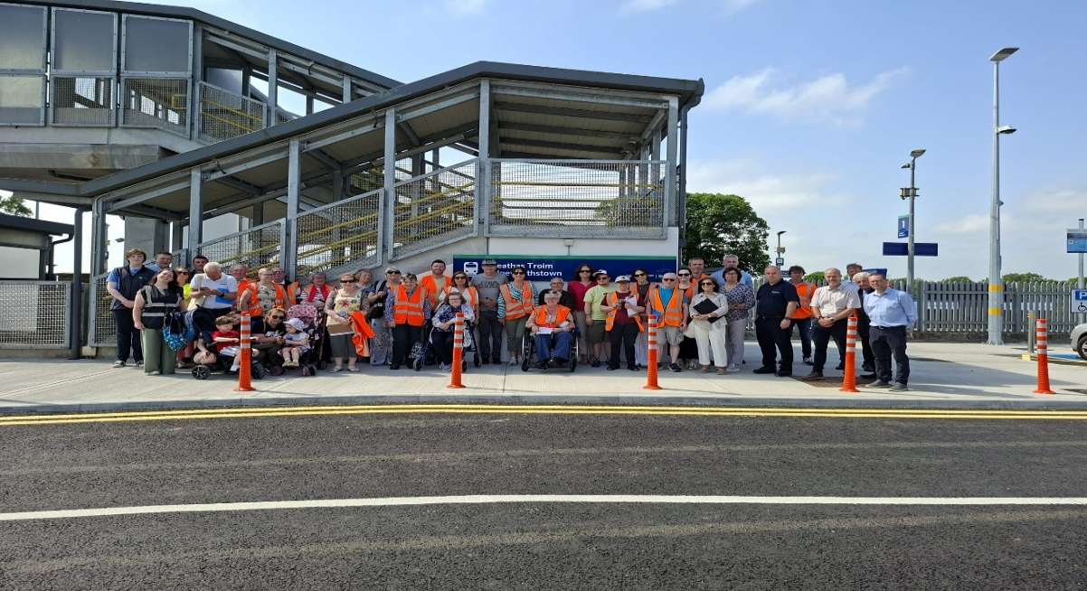
Photo above: Participants who attended the walkability audit.
Customer Experience Awards
The Iarnród Éireann Customer Experience Excellence Awards took place at the Aviva Stadium on 7 October, recognising colleagues who consistently deliver exceptional customer service.
Disability & Accessibility Category
Highly Commended
- Darragh Connolly - Train Host, Cork
- Patrick O'Callaghan - Train Host, Cork
- Brian Blake & Robert Shiels - Station Operatives, Portlaoise
- Ota Kral - Project Manager, Network Enhancements Team
Finalists
🏆 Winners: Eddie Whelan and Pat McGrath - Drumcondra Station
- Michelle Carey - Executive Accessibility Officer, Connolly Station
- Daniel Dowling - Station Operative, Kilkenny

Congratulations to all nominees and winners for their outstanding commitment to accessibility and customer service.

Auracast Demonstration
A recent demonstration of Auracast assistive listening technology took place at the Vision Ireland Wayfinding Centre.
Auracast enables people with hearing impairments to access audio content more easily in public spaces through compatible assistive listening devices.
Michelle Carey and Ronan Murphy attended on behalf of Iarnród Éireann.
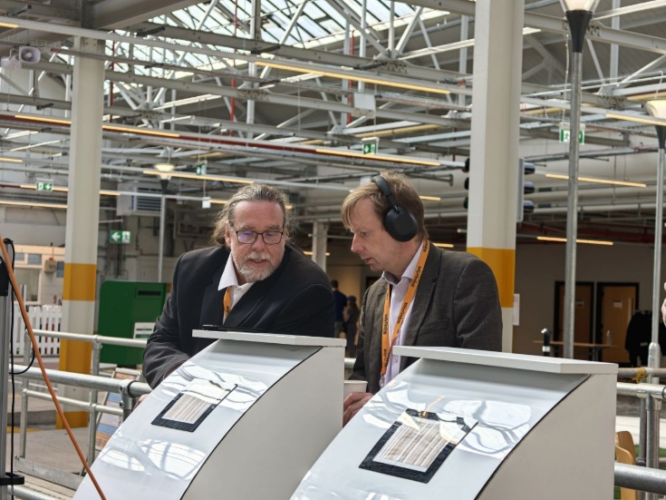
Photo above: Ronan Murphy, Iarnród Éireann.

Changing Places Ceannt Station
Iarnród Éireann is delighted to announce that the fourth Changing Places facility on the rail network is now open at Ceannt Station, Galway. Customers wishing to access the facility should contact station staff for assistance.

Positive Feedback received
"We travelled with my son Stephen, a wheelchair user, from Heuston to Kilkenny and back in September. We were delighted with the assistance provided by staff both on the platforms and onboard the trains. Their support made the journey easy and enjoyable. We are extremely grateful."
******************************************************************
"As a regular user of the assistance service, I just want to say thank you. The support provided allows me and many others to travel independently and with confidence. It makes a huge difference."

I'd like to acknowledge the efforts of the Irish Rail staff in assisting with getting on and off trains and general assistance in the stations. I'd especially like to recognise Abdel, in Colbert Station. He's consistently friendly, gracious and pleasant to deal
with. He's a very kind human being, and really good at his job. It makes the whole travelling experience more enjoyable

Using Iarnród Éireann Services

We encourage customers with disabilities to choose rail travel and hope the updates outlined above provide reassurance that accessibility remains a key priority across our network.
Booking Assistance - Intercity Services
Consolidated Call Centre: 0818 294 015
Opening Hours
- Monday to Friday: 7:00am to 7:00pm
- Saturday: 8:00am to 6:00pm
- Sunday & Bank Holidays: 10:00am to 6:00pm

For assistance on DART and Commuter services, please contact your local station. DART, Maynooth and Northern Commuter Accessibility Policy

