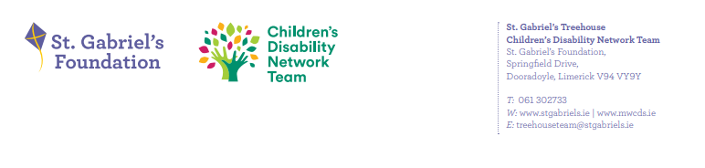
Reporting from Family Forums to Family Representative Group re Forum 9th March’26
- What developments have taken place since the previous forum meeting?

Family Rep KP updated family network:
- Karen Power & Kate Family Rep gave feedback from recent family rep meeting on the 20th of January, attended by Maria Boyle.
  - Topics covered in the meeting:
  - Budget for more therapists, KPI’s and stats
  - Mid-West most challenging in Ireland
  - Challenges in school’s lack of SNA’s
  - Lizette explained that the CDNT is home based practice
  - HSE Hub
  - Next meeting will be held on the 25th of March
  - Lizette gave feedback on Respite and explained to parents the term “respite”. – family to link with social worker on the team around application for respite.
Parent Rep Nominations:
- Kate – Kate introduced to herself to the team and parent(s) and reasoning for putting herself forward as a family rep. Kate is now a family rep for St Gabriel’s Treehouse team.
Parent Rep’s feedback to parent rep forum:
Wording of IFSP
SIB Shop
Websites
Documents for groups

Feedback from Lizette CDNM:
- Newsletter first edition of 2026 now available on our St Gabriel’s Foundation website
- Waitlist initiative, most families waiting over 12 months were contacted. A triage call was completed by clinicians out of hours. Parents on the waitlist were provided universal strategies and if appropriated invited to a range of webinars.
- Both the Sproai and Sonas team completed the Being Me Training- Neuro Affirmative practice
- Groups: the team is currently facilitating and planning to run the following groups in the next 2/3 months: early bird parent training, the transition to secondary school group, being me group, fussy feeders’ group.
- New post diagnostic support pathways was implemented by the Sproai Team
- Entrance to services was held on the 06/03/2026.
- Current waiting times: initial team assessment currently seeing children referral in July 2023. Waiting times for ASD currently seeing children in Feb 2023.
- Primary care redirect meetings

- What work was done/topics discussed at the meeting?

Parents Input/feedback
Question Raised:
- Where to apply for respite?
- Supports around school placement – SRFS
- The difference between waitlist and active on the team.
- Staffing – what are staffing numbers?

Small Group Discussion:
- Ideas on collaborative working:
- Previous suggested topics:
- Sib shop
- Access things out in the community
- Transition to adulthood

Discussed on the 09/03/2026:
- Younger person to be included in the wording of their IFSP’s
- A synopsis to be given on what groups are offered and why
- Agenda to be uploaded in a month in advance to website
- Text message to go out once website is updated.
- A group for siblings

- What were the main issues or areas of concern expressed by parents at the meeting?

What worked well:
- Information on courses
- Theme of the next meeting
- Clinicians attending – learning about parents’ concerns

What could we do to make the meeting better:
- Staffing on each team to understand understaffing
- Caseload numbers per age
- Being mindful of feedback to clinicians

Topics for next Family Forum:

- Clinician to be present for the next meeting to discuss groups running
- Website
- Parents reps to create next agenda

