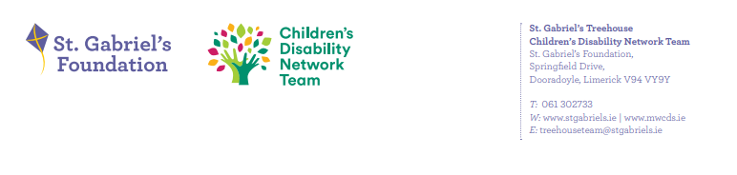
Reporting from Family Forums to Family Representative Group re Forum 9th Oct’25
- What developments have taken place since the previous forum meeting?
- Families Updated on Single Point Of Access for services engagement day, for newly referred families. This will allow for services to be more accessible.
- What Next Fair , hosted by the Blackberry Park CDNT with HSE day opportunities – 15-18 yr old invited. All CDNT families were invited.
- Fun day on 30th October for Junior Infants -9yrs old held in Mungret Club House.
- Kiddies Christmas Party scheduled for 9th Dec – 220 children invited.
- What work was done/topics discussed at the meeting?
- Updated new attendees on process of 4 Family Network Meeting per annum. Family Reps stepped down in early 2025. 3 new reps were nominated.
- Current family reps provided feedback from Regional Forum. Tracking document now being used by Family Regional Group to ensure that all issues raised are followed up.
- CDNM provided updates on waiting times, staffing, communication with new families and joint working practices with other agencies.
- Groups/events available in the community over midterm break, Docas Camp, Liskenneth, & UL Camp.
- Guest speaker, Special Education Needs Organiser– Elizabeth Breen, discussed supports provided to schools by the NCSE.

What families would like in 2026:
- Parents would like to be aware of upcoming parent groups/programmes so that they can indicate to the team if they would like to attend.
- Information concessionary access for schools.
- Guest Speaker to discuss some of the following topics:
  - Benefits & Entitlements, including appeal process.
  - How to navigate using Disability Allowance for young people
  - How young people can learn to budget their money
  - Augmentative and Alternative Communication information

- What were the main issues or areas of concern expressed by parents at the meeting?
Likes
- Guest Speaker, covering requested topics.
- Option to connect with others over coffee
- Breakout sessions/ small group discussions
- Discussion on terminology
Dislikes
- Discussion on use of acronyms

