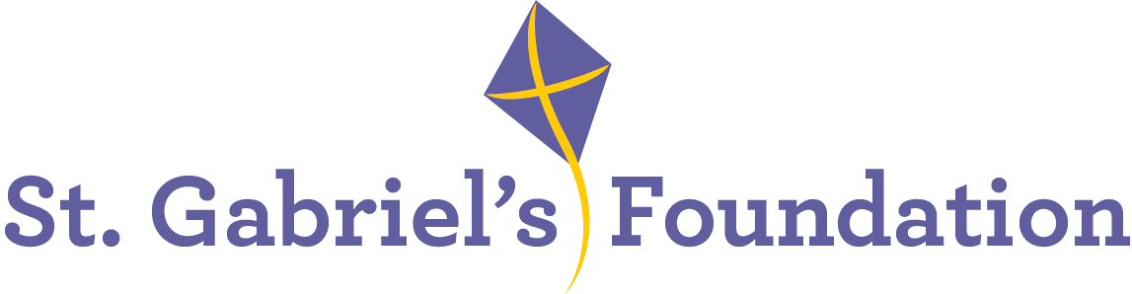

St. Gabriel’s is a Voluntary Organisation based in Limerick. St Gabriel’s provides services and therapeutic interventions to children and adults with disabilities through their Children’s Disability Network Teams, Hydrotherapy Pool, Orthotics Department and Respite House.

St. Gabriel’s is the Lead Agency for two Children’s Network Disability Teams; Treehouse Team covering Community Health Care Network 6 and South City Team which covers Community Healthcare Network 7.
It is also the Lead Agency for the Mid-West Disabilities AON for Children Assessment Pathway Team.

We wish to recruit the following highly motivated and enthusiastic staff members to join the
Children’s Disability Network Team in the following roles:

Senior and Staff Grade Psychologist

Informal enquiries to: ashinners@stgabriels.ie

Application form, job description and job specification are available from:
cdillon@stgabriels.ie

This post will facilitate the continued implementation of PDSCYP with emphasis on optimal achievement of outcomes for children and their families. This model includes a focus on development and enhancement of collaborative working with families, schools, and pre-schools to support children with complex disability to achieve their full potential.

Senior Psychologist: The successful candidate must have:
Applicants must have a recognised university degree or diploma (QQ1 level 8 equivalent) obtained with 1st or 2nd-class honours in which Psychology was taken as a major subject and honours obtained in that subject AND a recognised post-graduate professional qualification in clinical, counselling or educational psychology or an equivalent qualification validated by the Department of Health (PSI).
AND
Applicants must have at least five years satisfactory post-graduate experience in the area of professional psychology, no more than three years of which was spent in gaining the post-graduate professional qualification and no less than two years full-time spent in post qualification experience as a professional psychologist. Years in excess of the permitted three years for completion of the post-graduate training or time not worked will not be taken into consideration when assessing the five years' experience requirement.
AND
Applicants with a clinical or counselling psychology qualification must demonstrate that they have acquired in appropriate health settings, for the areas for which they wish to apply - Disability (Child and Adult), Child Psychology, Adult Psychology either at least 60 days or equivalent supervised clinical placements as part of the professional qualification or at least 60 days or equivalent post qualification supervised work experience as a psychologist.
Previous psychology experience working with children with a range of disabilities including physical, sensory, intellectual and autism spectrum disorder.

Staff Grade Psychologist: The successful candidate must have:
Applicants must have a recognised university degree or diploma (Quality and Qualifications Ireland (QQI) level 8 equivalent) obtained with 1st or 2nd class honours in which Psychology was taken as a major subject and honours obtained in that subject AND a recognised professional post-graduate qualification in clinical, counselling or educational psychology or an equivalent qualification validated by the Department of Health.

AND
Applicants with a clinical or counselling psychology qualification must demonstrate that they have acquired in appropriate health settings, for - Disability (Child and Adult), either at least 60 days or equivalent supervised clinical placements as part of the professional qualification or at least 60 days or equivalent post qualification supervised work experience as a psychologist.
OR
Applicants with an educational psychology qualification must demonstrate that they have acquired in appropriate health settings for Child Disability, either at least 60 days or equivalent supervised clinical placements as part of the professional qualification or at least 60 days or equivalent post qualification supervised work experience as a psychologist.
Note: Combinations of supervised clinical placement experience as part of the qualification and post qualification supervised work experience within a single care group area to give a total of 60 days are not acceptable.

The 60 days of supervised placements do not have to be acquired consecutively. However no more than three separate supervised placements, each with a minimum of 20 consecutive days, should be counted to make up the sixty days. For example, a candidate could have completed three separate supervised placements of 20 days duration in different semesters, months, years etc., this would also satisfy the 60 day requirement.

What we offer:
- Paid holidays
- Comprehensive learning & development program
- Bike to work scheme
- Pension
- Employee Assistance Programme
- Flexible Supportive Workplace

All applicants must be eligible to work in Ireland

Shortlisting may apply
Closing date for receipt of application: Friday 26th September @ 5pm

Canvassing will disqualify
St. Gabriel’s is an Equal opportunities employer

