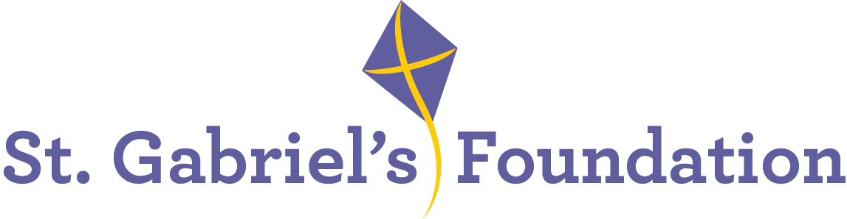

St. Gabriel’s is a Voluntary Organisation based in Limerick. St Gabriel’s provide services and therapeutic interventions to children and adults with disabilities through their Children’s Disability Network Teams, Hydrotherapy Pool, Orthotics Department and Respite House.

St. Gabriel’s is the Lead Agency to two Children’s Network Disability Teams; Treehouse Team covering Community Health Care Network 6 and South City Team which covers Community Healthcare Network 7.

Due to the allocation of additional posts, we wish to recruit the following highly motivated and enthusiastic staff members to join the
Children’s Disability Network Team in the following roles:

Senior Social Work Practitioner
Social Work Team Leader

A panel may be formed for similar positions that may arise within our organisation.

Informal enquiries to: ashinners@stgabriels.ie

Application form, job description and job specification are available from:
swalsh@stgabriels.ie

Senior Social Work Practitioner: The ideal candidate will hold a relevant qualification and have a minimum of 3 years’ post graduate experience subsequent to obtaining that qualification. Applicants must be registered with CORU or eligible to be registered with CORU.
This post will facilitate the continued implementation of PDSCYP with emphasis on optimal achievement of outcomes for children and their families. This model includes a focus on development and enhancement of collaborative working with families, schools, and pre-schools to support children with complex disability to achieve their full potential.

Social Work Team Leader: The ideal candidate will hold a relevant qualification and have a minimum of 5 years’ post graduate experience with a minimum of 3 years working with families. Applicants must be registered with CORU or eligible to be registered with CORU.
The purpose of the post is to manage the provision of a social work service within an inter-disciplinary context and in so doing providing a family centred service to children and their families in the community.

What we offer:
- Competitive salary
- Paid holidays
- Comprehensive learning & development program
- Bike to work scheme
- Pension
- EAP
- Flexible Supportive Workplace
All applicants must be eligible to work in Ireland

Shortlisting may apply
Closing date for receipt of completed application form: Monday 30th June 2025 @ 5 pm

Canvassing will disqualify
St. Gabriel’s is an Equal opportunities employer

