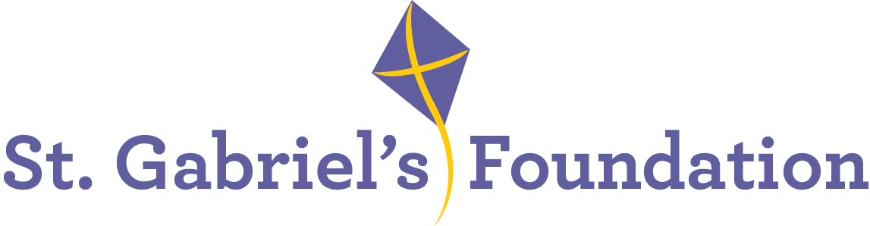

St. Gabriel’s is a Voluntary Organisation based in Limerick. St. Gabriel’s provide services and therapeutic interventions to children and adults with disabilities through their Children’s Disability Network Teams, Hydrotherapy Pool, Orthotics Department and Respite House.

St. Gabriel’s is the Lead Agency to two Children’s Network Disability Teams; Treehouse Team covering Community Health Care Network 6 and South City Team which covers Community Healthcare Network 7.

We wish to recruit the following highly motivated and enthusiastic staff member to join the
Children’s Disability Network Teams in the following roles:

Staff Grade Speech & Language Therapist (Full-time/Part-Time)
A panel may be formed for similar positions that may arise within our organisation.

Informal enquiries to: lmarais@stgabriels.ie

Application form, job description and job specification are available from:
Christine Dillon, cdillon@stgabriels.ie

Staff Grade Speech & Language Therapist Post:
This post will facilitate the continued implementation of PDSCYP with emphasis on optimal achievement of outcomes for children and their families. This model includes a focus on development and enhancement of collaborative working with families, schools and pre-schools to support children with complex disability to achieve their full potential. Applicants must be registered with CORU or eligible to be registered with CORU.

What we offer:
- Paid holidays
- Comprehensive learning & development program
- Bike to work scheme
- Pension
- EAP
- Flexible Supportive Workplace
All applicants must be eligible to work in Ireland

Shortlisting may apply
Closing date for receipt of completed application form: 13th June 2025 @ 5 pm

Canvassing will disqualify
St. Gabriel’s is an equal opportunity employer

