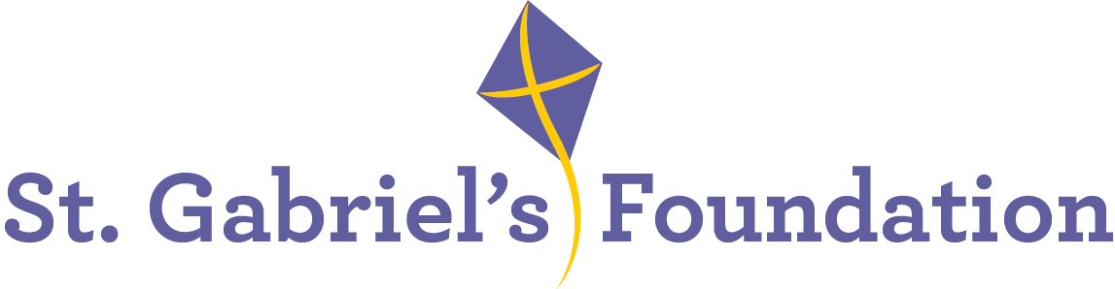

St. Gabriel’s Children’s Respite House
St. Gabriel’s is a Voluntary Organisation based in Limerick providing therapy and education services to children with disabilities. St. Gabriel’s has a large nursing unit supporting the children who attend St. Gabriel’s school. We also have a purpose-built six-bedroom respite house specifically to meet the needs of children with complex physical disabilities and additional medical needs living in the Mid-West Region. To view the respite house, go to https://drive.google.com/file/d/1IYUk0-gR5Z8BbJ_fFSIU8oeOaz32FAnb/view

Due to the expansion of our services, we wish to recruit the following highly motivated and enthusiastic staff members for permanent, temporary full-time, part-time, and relief employment in the roles of

Staff Nurses and Healthcare Assistants
Permanent/Temporary full-time/Part-time/Relief
Location: St. Gabriel’s Children’s Respite House, Mungret

Staff Nurse - Essential experience, skills and abilities
- Registered with the Register of Nurses & Midwives maintained by the Nursing and Midwifery Board of Ireland.
- Experience of working in a health or social care setting.
- Demonstrate good interpersonal communication skills and have a positive attitude towards staff, children with special needs, their parents and carers.
- Possess effective administrative skills - oral, written, IT.
- Currently eligible to work in Ireland.

Desirable
- Experience supporting ADLs of children with disabilities, complex medical needs and life limiting conditions.
- Experience working in a HIQA designated residential and/or respite centre.
- Ability to demonstrate understanding and skill in the management of enteral/ tube feeding/epileptic seizure management.
- Ability to contribute to skills training of children in the areas of social and personal care that will contribute to their personal development and independence.
- An understanding of the principles of community inclusion for children with disabilities.

Healthcare Assistant – Essential Experience, skills and abilities
- Minimum FETAC Level 5 Healthcare Assistant or equivalent in a relevant healthcare discipline.
- Excellent interpersonal and IT skills.
- Currently eligible to work in Ireland.
- Demonstrate good interpersonal communication skills and have a positive attitude towards staff, children with special needs, their parents and carers.
Desirable:
- Experience working with children with complex medical needs such as epilepsy, enteral feeding and technology dependant.
- Experience working in a HIQA designated centre.

What we offer:
- Paid holidays
- Comprehensive learning & development program
- Bike to work scheme
- Pension
- Employee Assistance Programme
- Flexible Supportive Workplace

Informal enquiries to:
Ms Elaine O’Riordan, (Person in Charge) Manager, St. Gabriel’s Children’s Respite House,
Tel: 086 075 9397 email: eoriordan@stgabriels.ie

Application form, job description and job specification are available from:
Christine Dillon
Email: cdillon@stgabriels.ie

Shortlisting may apply

Closing date for receipt of completed application form:
on or before 12 noon Friday, 18th April 2025

Canvassing will disqualify
St. Gabriel’s is an Equal opportunities employer

