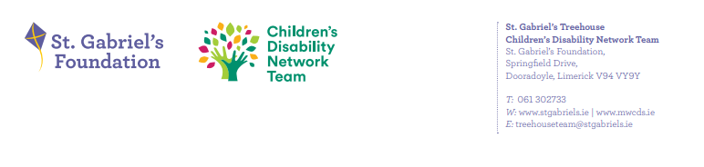
Reporting from Family Forums to Family Representative Group re Forum 13th Feb’25
- What developments have taken place since the previous forum meeting?
- An Entry To Services booklet has been developed in response to feedback received from families and will be received by new families with the acceptance to services letter. A new intake process was developed with young people and a regional Individual Family Service Plan leaflet was developed in addition to the regional CDNT website having been updated.
- The team plan to start communicating more often with families on the waiting list the aim is to write to families on the waiting list twice yearly to update on waiting times.
- Newsletter in development. Expected roll out date late Q1.
- Minutes of November’24 Family Network meeting available on St. Gabriel’s website.
- What work was done/topics discussed at the meeting?
- Updated new attendees on process of 4 Family Network Meeting per annum. Current Family Reps are stepping down in early 2025. Nomination forms will be available on the website for parents interested in volunteering to become a Family Network Meeting Parent representative. Parents to complete the form for the next Family Network Meeting.
- Current family reps provided feedback from Regional Forum. Tracking document now being used by Family Regional Group to ensure that all issues raised are followed up.
- CDNM provided updates on projects completed over the Summer for example the young person focus groups and design of the initial appointment process with young people. The regional development of the Individual Family Centred Plan leaflet, entry to services booklet and the development of the Regional CDNT website. Staffing and upcoming high level of maternity leave discussed.

What families would like in 2025:

- Parents would like to be aware of upcoming parent groups/programmes so that they can indicate to the team if they would like to attend: Understanding Autism, All about Autism, What’s Next Fair Transition to Secondary School
- What would families like to see in the waiting room : Families were in favour of having a QR code for feedback for service.
QR code for St Gabriel’s website.
Info re events happening in the community & groups which St. Gabriel’s will be running.
Glofox app for Hydrotherapy pool
Info for those who are aging out
#How to update personal information

- What were the main issues or areas of concern expressed by parents at the meeting?
- Optimising parents accessing groups/parent courses. Discussed the options of offering courses to parents on waiting lists when there is low attendance at first session of a group.
- Discussed how to change wording of text for family morning in Southill hub to increase attendance.
- Parents to be notified when school visits are completed for their children.
- Looking at how to provide parents with upfront information regarding major life transitions for example a child transitioning from Pre-school to Primary school, Primary school to Secondary school or a young person transitioning to adult services.

