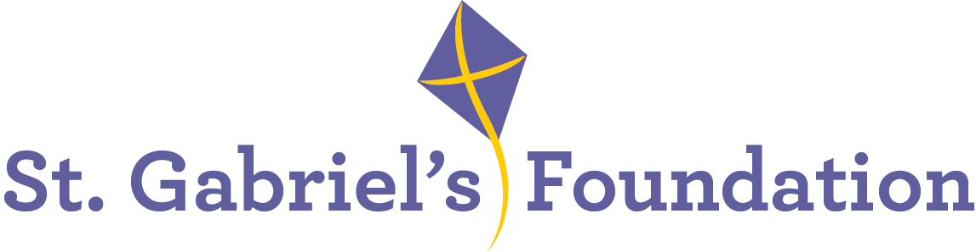

St. Gabriel’s is a Voluntary Organisation based in Limerick. St Gabriel’s provides services and therapeutic interventions to children and adults with disabilities through their Children’s Disability Network Teams, Hydrotherapy Pool, Orthotics Department and Respite House.

St. Gabriel’s is the Lead Agency to two Children’s Network Disability Teams; Treehouse Team covering Community Health Care Network 6 and South City Team, which covers Community Healthcare Network 7.
It is also the Lead Agency for the Mid-West Disabilities AON for Children Assessment Pathway Team.

We wish to recruit the following highly motivated and enthusiastic staff members to join the
Children’s Disability Network Teams in the following role:

Senior Occupational Therapist – 1WTE

A panel may be formed for similar positions that may arise within our organisation.

Informal enquiries to: ashinners@stgabriels.ie

Application form, job description and job specification are available from:
Christine Dillon, cdillon@stgabriels.ie

The post will facilitate the continued implementation of PDSCYP with emphasis on optimal achievement of outcomes for children and their families. This model includes a focus on the development and enhancement of collaborative working with families, schools, and pre-schools to support children with complex disability to achieve their full potential. The post will focus primarily on assessment as part of the Mid-West Disabilities AON for Children Assessment Pathway Team.

The successful candidate will hold relevant qualifications, with a minimum of 3 years post qualification with paediatric assessment experience. Applicants must be registered with CORU

. What we offer:
- Paid holidays
- Comprehensive learning & development program
- Bike-to-work scheme
- Employee Assistance Programme
- Flexible Supportive Workplace
All applicants must be eligible to work in Ireland

(Applications must be made on St. Gabriel’s Application Form only, CVs will not be accepted)

Shortlisting may apply
Closing date for receipt of completed application form: 4.30 pm Thursday, 17th April 2025

Canvassing will disqualify
St. Gabriel’s is an Equal opportunities employer.

