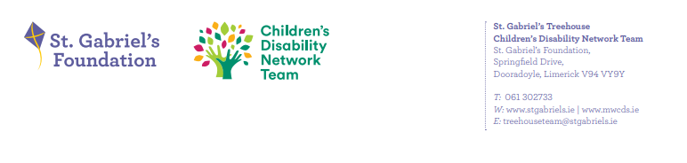
Reporting from Family Forums to Family Representative Group re Forum 27th November
- What developments have taken place since the previous forum meeting?
- Family Connect Day in Southill Hub in October’24
- Teen Focus Group. Positive feedback from all who attended. Next step will be to involve the IFSP with young people.
- Positive feedback received for the SENO talk for 2025 school starters, Sleep Management Course
- What work was done/topics discussed at the meeting?
- Updated new attendees on process of 4 Family Network Meeting per annum. Current Family Reps are stepping down in early 2025. Tose who would like to nominate themselves will have an opportunity to discuss with current reps, to gather further information.
- Current reps updated feedback from Regional Forum
- What families would like in 2025:
- Groups that parents can book into for the wider caseload. Review possibility of Splash/Cycling Summer Group.

- What were the main issues or areas of concern expressed by parents at the meeting?
- Waiting times for Initial Contact & Autism assessments

