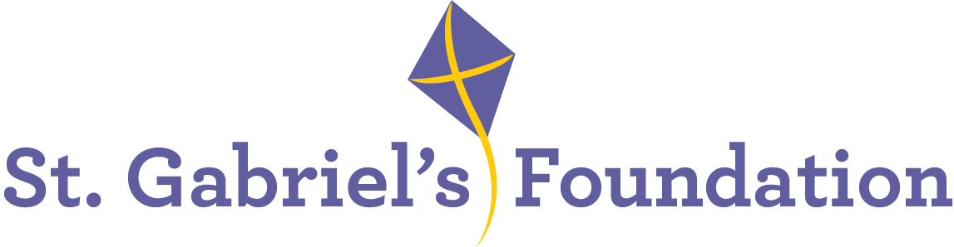

St. Gabriel’s is a Voluntary Organisation based in Limerick. St Gabriel’s provide services and therapeutic interventions to children and adults with disabilities through their Children’s Disability Network Teams, Hydrotherapy Pool, Orthotics Department and Respite House. Please visit https://www.stgabriels.ie for comprehensive information on our organisation and its range of services.

We wish to recruit the following highly motivated and enthusiastic staff member to work in
our busy Fundraising Department:

Fundraising & Marketing Executive
1 x One Year Fixed Term, Full-Time

Essential:
- Minimum 2 years’ experience in a similar role
- A degree in marketing/business or a related field, or equivalent “on the job” experience.
- Excellent IT skills particularly Excel, Word, Powerpoint and Canva
- Excellent oral, verbal and written English communication skills
- Experience in website management
- Attention to detail, flexibility and adaptability in the role are essential
- Ability to multi-task and to work on own initiative
- Ability to meet tight deadlines
- Currently eligible to work in Ireland
- Full Clean Irish Driving License and access to a vehicle

Desirable

- An understanding of the disability sector and associated support services.
- Previous experience working in a not-for-profit environment.
A panel may be formed for similar positions that may arise within our organisation.

Informal enquiries to:
Ms Kate Finucane, Fundraising Manager
Tel: 0857158573 email: kfinucane@stgabriels.ie

Applications must be made on the St. Gabriel’s Application Form.
Job Description and Application Form available from cdillon@stgabriels.ie
(CV’s can be submitted in addition to Application Form.)

Shortlisting may apply
Closing date for receipt of application is: 12noon Friday March 14th 2025
Interviews will take place on Wednesday March 19th.

Canvassing will disqualify
St. Gabriel’s is an Equal opportunities employer

